**Assignment – 3**

**Financial Analytics**

**Title : Analyzing competitive advantage in real companies**

**CONTENT**

* **Introduction**
* **Background**
* **Competitive advantage**
* **Financial performance evaluation**
* **Comparative analysis**
* **Assessment of sustainability**
* **Conclusion**

In this task I am analysing the competitive advantage of two real companies operating in different industries. One company from technology sector i.e. **APPLE** and another from the consumer goods sector i.e. **DABUR LTD**.

* **Introduction**
* **Company from technology sector :** **APPLE Inc**



**Apple Inc.** (formerly **Apple Computer, Inc.**) is an American multinational corporation and technology company headquartered in Cupertino, California, in Silicon Valley. It designs, develops, and sells consumer electronics, computer software, and online services. Devices include the iPhone, iPad, Mac, Apple Watch, Vision Pro, and Apple TV; operating systems include iOS, iPadOS, and macOS; and software applications and services include iTunes, iCloud, Apple Music, and Apple TV.

For most of the period between 2011 and 2024, Apple was the world's largest company by market capitalization until it lost this position to Microsoft in January 2024.In 2022, Apple was the largest technology company by revenue, with US$394.3 billion. As of 2023, Apple was the fourth-largest personal computer vendor by unit sales, the largest manufacturing company by revenue, and the largest vendor of mobile phones in the world. It is one of the Big Five American information technology companies, alongside Alphabet (the parent company of Google), Amazon, Meta (the parent company of Facebook), and Microsoft.

* **Company from consumer goods sector** : **DABUR INDIA LIMITED**



Dabur India Ltd. is one of the leading consumer goods companies in India, specializing in health care, personal care, and food products. Established in 1884 by Dr. S.K. Burman, Dabur has grown from a small pharmacy in Kolkata to a multinational corporation with a diverse portfolio of brands.

Headquartered in Ghaziabad, India, Dabur operates across multiple categories including Ayurvedic medicines, natural healthcare products, oral care, hair care, skin care, home care, and food products. The company's extensive product range includes popular brands such as Dabur Chyawanprash, Dabur Honey, Dabur Red Toothpaste, Vatika hair oil, and Real fruit juices, among others.

Dabur's success is built on its commitment to Ayurveda, an ancient Indian system of medicine, and its focus on offering natural and herbal products that promote health and well-being. The company combines traditional Ayurvedic wisdom with modern scientific research to develop innovative and effective products that cater to the needs of consumers in India and abroad.

With a strong distribution network spanning over 100 countries, Dabur has a significant presence in international markets as well. The company's emphasis on quality, innovation, and sustainability has earned it the trust and loyalty of millions of consumers worldwide.

* **Background**

1. **Company name : Apple Inc**

Apple Inc (Apple) designs, manufactures, and markets smartphones, tablets, personal computers, and wearable devices. The company offers software applications and related services, accessories, and third-party digital content. Apple’s product portfolio includes iPhone, iPad, Mac, iPod, Apple Watch, and Apple TV.

It also provides advertising services, payment services, cloud services, and various consumer and professional software applications such as iOS, macOS, iPadOS, watchOS, iCloud, AppleCare, and Apple Pay. Apple sells and delivers digital content and applications through the App Store, Apple Arcade, Apple News+, Apple Fitness+, Apple Card, Apple TV+, and Apple Music.

1. **Company name : DABUR INDIA LIMITED**

Dabur India Limited is one of the leading consumer goods companies in India, specializing in health care, personal care, and food products. Founded in 1884 by Dr. S.K. Burman, it initially started as a small pharmacy in Calcutta (now Kolkata) before expanding into a multinational corporation. Dabur's product portfolio includes well-known brands such as Dabur Chyawanprash, Dabur Honey, Vatika hair oil, and Real fruit juices, among others. The company is known for its focus on natural and Ayurvedic ingredients, catering to a growing consumer demand for healthier alternatives. Over the years, Dabur has established a strong presence not only in India but also in various international markets. It is committed to sustainable practices and community development initiatives, contributing to its reputation as a socially responsible organization.

* **Competitive advantages**

comparing competitive advantages of both the companies.

|  |  |  |  |
| --- | --- | --- | --- |
| **Company name** | **APPLE Inc** | **DABUR INDIA LTD** |  |
| **Brand reputation** | Apple is viewed favourably for its “products and corporate performance,” but the company’s rating was hurt by poor performance from n its “citizenship” category. The Reputation Institute, an organisation that provides consulting services to corporate communications and marketing executives, conducts its study by surveying consumers and other stakeholders about their opinions on major companies, In 2017, Apple scored 74.94 in the study, down 1.7 compared to the prior year. | Over the past 139 years, Dabur has built on its reputation of being the Most Trusted and the World's Largest Natural and Ayurvedic Healthcare company, by developing and successfully introducing products based on Ayurveda to offer our consumers holistic health and well-being. |  |
| **Product differentiation** | In the ever evolving landscape of deception and disguise, product differentiation plays a viatl role in the market place. By patenting its unique designs and innovative features, apple can differentiate its products from competitors. The differentiation attracts consumers who value design and users experience. | Dabur India Limited stands out in the consumer goods market through its emphasis on natural and Ayurvedic products, combined with a rich heritage and strong brand equity. Dabur's commitment to offering products rooted in Ayurveda and natural ingredients resonates with consumers seeking wellness-focused alternatives in personal care, healthcare, and home care segments. This focus on natural formulations not only differentiates Dabur's products but also aligns with the growing trend towards health-conscious consumer choices. needs and preferences. Leveraging its deep-rooted heritage dating back to 1884, Dabur has built a robust brand equity characterized by trust and reliability demands. |  |
| **Technological innovation** | Nearly five decades after its founding, Apple has become one of the world’s most valuable companies. But beyond its $3 trillion market value, the technology supergiant has also shaped 21st-century society and culture. From the invention of the MacBook to the introduction of the iPhone, Apple paved the way for the world’s future generation of  technological products. Of all product releases over the years, here are six of the most groundbreaking Apple product innovations. Such as the mac, iPhone, iPod, iPad, apple watch, etc. | Dabur India Ltd. innovates by integrating technology into its Ayurvedic and natural products, enhancing quality and efficacy. The company utilizes advanced processes for research, formulation, and production, ensuring the development of cutting-edge wellness solutions. Through technology, Dabur continues to uphold its legacy of delivering trusted and effective healthcare products. |  |
| **Market leadership** | Apple is a leader in innovation and manages to set trends with each product it launches on the market, this has been proven time and time again, revolutionising the technological world.  We can highlight the following examples: 1) adaptation to customer needs, 2)commitment to design, 3) Quality before quantity 4) Excellent customer service. | Dabur India Ltd. maintains market leadership in the consumer goods sector by leveraging its heritage, brand equity, and focus on natural and Ayurvedic products. With a diverse portfolio spanning personal care, healthcare, and home care segments, Dabur continues to innovate and meet evolving consumer preferences, reinforcing its position as a trusted wellness brand. |  |
| **Distribution network** | Apple is one of the leading technology companies in the world, making everything from phones to computers to earphones. They have really created a full ecosystem to connect all their products and services. Apple has 510 stores worldwide but also sells its products through third-party sellers and carrier providers. Components are made all over the world by specialist of each part and sent to two main assemblers in China to manufacture the final product, Foxconn and Pegatron. | Dabur India Limited maintains an extensive distribution network that reaches both urban and rural markets across India and several international markets. Through strategic partnerships and efficient logistics, Dabur ensures wide availability of its natural and Ayurvedic products, strengthening its market presence and serving diverse consumer segments effectively. |  |

* **Analysing financial performance**
* **Analysing financial performance of**

**Technology company : APPLE**

1. **Revenue growth:** Apple today announced financial results for its fiscal 2024 first quarter ended December 30, 2023. The Company posted quarterly revenue of $119.6 billion, up 2 percent year over year, and quarterly earnings per diluted share of $2.18, up 16 percent year over year.

For the first quarter of their 2024 fiscal year, Apple reported a revenue of 119.6 billion U.S. dollars.

1. **Profit margins:**

Profit margin can be defined as the percentage of revenue that a company retains as income after the deduction of expenses. Apple net profit margin as of December 31, 2023 is 26.16%.

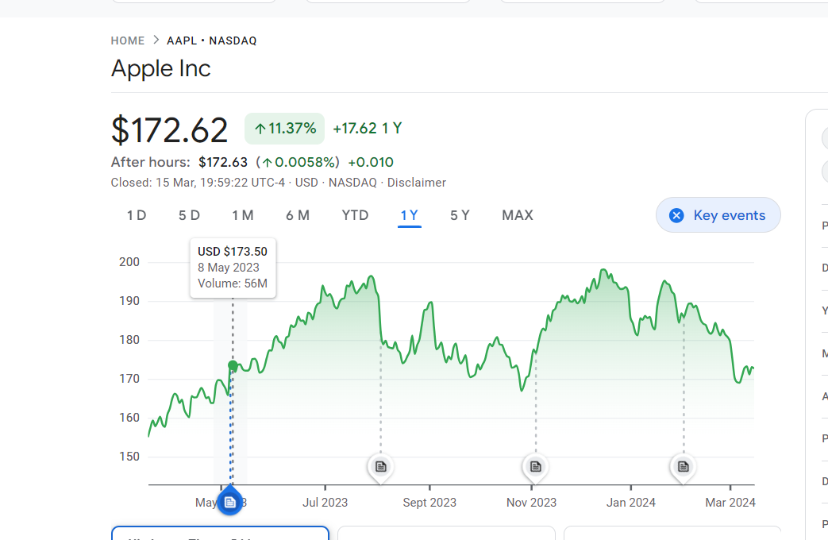

1. **Return on investment:**

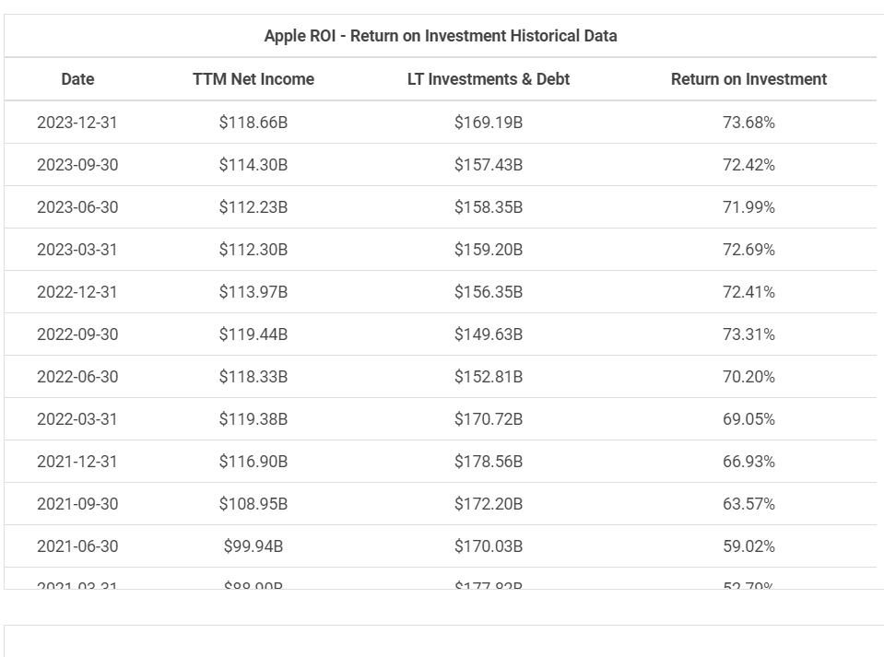

1. **Market share :**

Market share of Apple iPhone smartphone sales worldwide 2007-2023. Apple claimed a 24.7 percent share of the market in the fourth quarter of 2023, an increase from the previous quarter. Apple's long time competitor, Samsung, ranked first with a market share of 16.3 percent.

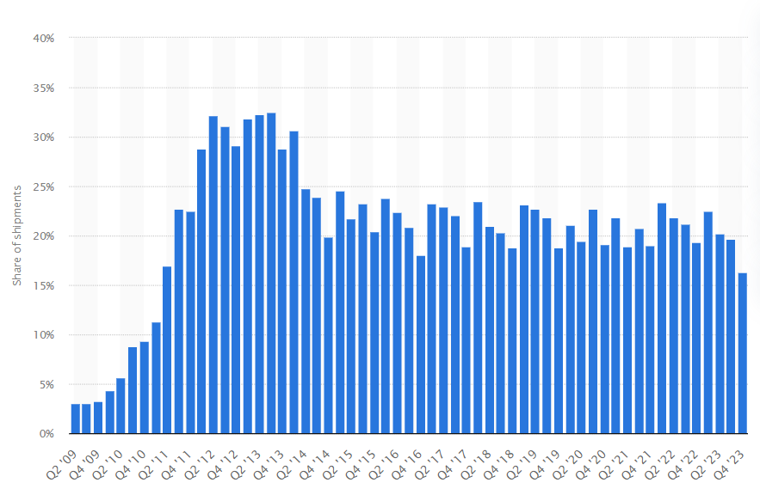

* **Analysing financial performance of**

**Consumer goods service company : DABUR INDIA LTD**

1. **Revenue growth:**

Dabur India Limited ended the third quarter of 2023-24 with a 7% growth in Revenue from Operations at Rs 3,255 Crore, driven by steady performance of both the Home & Personal care and Food & Beverages businesses. Revenue stood at Rs 3,043.2 Crore in Q3 of 2022-23.

1. **Profit margin:**

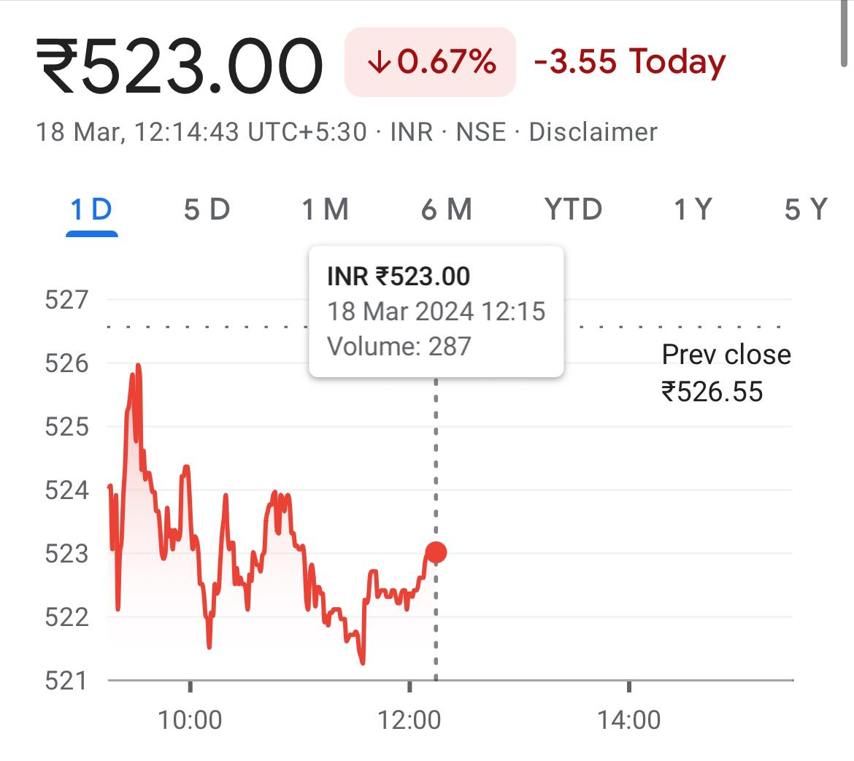

1. **Return on investment:**

ROE Ratio of Dabur India Ltd. with value of 19.61 means its generates profits efficiently by using its Shareholders Fund. ROE Ratio of DABUR has fallen by -8.32 % Compared to previous Financial Year.

1. **Market share:**

Riding on this demand, Dabur reported a strong 30% growth in sales and also reported a gain in markets share to capture 61.3% market share of J&N category in 2022-23

* **Compare competitive positions**

|  |  |  |
| --- | --- | --- |
| **Company name** | **Apple Inc** | **DABUR INDIA LTD** |
| **Market share** | Market share of Apple iPhone smartphone sales worldwide 2007-2023. Apple claimed a 24.7 percent share of the market in the fourth quarter of 2023, an increase from the previous quarter. Apple's long time competitor, Samsung, ranked first with a market share of 16.3 percent. | Dabur India Ltd., operating in the Personal Care sector and classified as a Largecap on the bse, currently has its share price at 522.85 The stock has experienced fluctuations today, with a low of ₹521.5 and a high of ₹526.55 Over the past 52 weeks, the shares have seen a low of ₹504 and a high of ₹596.9. |
| **Growth prospects** | Apple's Growth Strategies (Ansoff Matrix) product development. Apple uses product development as its main intensive strategy for growth. Product development requires that the company develop attractive and profitable technology products to grow its market share and business performance. | Tower India Ltd demonstrates promising growth prospects with its strategic positioning in the telecommunications infrastructure sector. As demand for network expansion and 5G deployment increases, the company is well-positioned to capitalize on opportunities, expand its market presence, and drive revenue growth in the evolving telecommunications landscape. |
| **Competitive threats** | Antitrust concerns and criticism of high app store fees relate to the power dynamics and control Apple exercises within its ecosystem, impacting competition and fair market practices. This goes beyond just business decisions and raises questions about governance, ethical conduct, and responsible use of market power. | Dabur India Ltd. contends with competitive threats from both domestic and international consumer goods companies across its diverse product categories. Challenges include shifting consumer preferences, price competition, and regulatory changes. To mitigate these threats, Dabur focuses on innovation, brand building, and market expansion strategies. |
| **Barriers to entry** | **High capital requirements:**Building a company to compete with Apple would require significant investments in technology, R&D, and marketing.  **Brand recognition:** Apple has a strong brand that is well-known and respected worldwide. | Dabur India Limited encounters notable entry barriers in the consumer goods market due to brand loyalty, extensive distribution networks, and regulatory compliance requirements. High investments in research, development, and marketing are necessary to compete effectively, posing challenges for new entrants attempting to penetrate the industry. |

* **Assessment of sustainability**

Sustainability assessment requires an evaluation of present and future conditions to show that present decisions and actions are not compromising future human and ecological health and well-being.

1. Technology company: **APPLE** **Inc**

Apple put sustainability at the centre of its Fall iPhone and Apple Watch event. It did so as it put sustainability into context by showing that you can do what I've been advocating for a long time: doing good and doing well from a business perspective.

Tim Cook opened up the event, saying Apple wants to make a difference as a company and with the products it brings to market. Apple Watch is the first carbon-neutral product that Apple launched, the first step towards its goal to have all Apple products be carbon-neutral by 2030.

It is important to take a moment to look at the steps that Apple is taking to achieve this goal. Apple’s first carbon-neutral products is a milestone in a journey initiated over a decade ago, involving substantial innovation and efforts throughout its global supply chain.

In 2020, the company reached carbon neutrality for its worldwide corporate operations and revealed the ambitious "Apple 2030" strategy to achieve carbon neutrality across its entire value chain by 2030. Central to this plan is a drastic 75% reduction of its total carbon emissions from the levels recorded in 2015. It has already diminished emissions by over 45% since 2015, even with revenue growing by over 65% within the same timeframe.

1. **Consumer goods sector**: **DABUR INDIA LTD**

Dabur also focuses on Sustainable Sourcing by partnering with farmers to promote organic farming practices, biodiversity conservation, and fair trade. By sourcing raw materials ethically, Dabur ensures the sustainability of its supply chain while supporting local communities.

Environmental Stewardship is another key aspect of Dabur's sustainability efforts, with a focus on reducing water consumption, energy usage, and greenhouse gas emissions. The company invests in renewable energy and waste management solutions to minimize its environmental footprint.

Community Development is integral to Dabur's sustainability strategy, with initiatives focusing on education, healthcare, and rural development. Through the Dabur Foundation, the company supports various social welfare programs and initiatives aimed at empowering marginalized communities.

Overall, Dabur India Ltd. has demonstrated a strong commitment to sustainability, incorporating ethical practices and social responsibility into its core business operations while driving positive impact across its value chain and beyond.

* **Conclusion**

1. **APPLE Inc**

Apple has changed the world through its products. The effects on consumers is phenomenon and only the future knows what products the Apple is going to bring to the market if their past trend is anything to go by, and it is likely to remain a giant for a long time. They have come up with products that people never imagined they needed, but once introduced to them they became hooked.

Apple is a maverick in the technology world, and the successful strategies they employ are likely to keep the company on an upward trend, consolidating its lead and market share. The company has huge cash reserves at its disposal that it can use to develop products.

Apple has accumulated significant cash reserves that have fortified its business. Even while the company faced multiple quarters of revenue declines this year, it continued to invest heavily in its high-growth industries like AI.

1. **DABUR INDIA LIMITED**

Dabur India Ltd. stands as a beacon of trust and innovation in India's consumer goods industry, with a rich heritage dating back to 1884. The company's unwavering commitment to Ayurveda, natural ingredients, and wellness has solidified its position as a trusted household name.

Dabur's diverse product portfolio, encompassing personal care, healthcare, and home care segments, caters to a wide range of consumer needs, reflecting its adaptability and market responsiveness.

Through sustainable sourcing practices, environmental stewardship, and community development initiatives, Dabur demonstrates its dedication to social responsibility and ethical business conduct. As India's consumer market continues to evolve, Dabur's focus on innovation, quality, and consumer satisfaction positions it strongly for sustained growth and continued leadership in the years ahead.

***